Name: CH. PURNIMA Register Number:192411048
Course: Object Oriented Analysis and Course Code: CSA1137
Design With Design Patterns

LAB EXPERIMENTS
1. LIBRARY MANAGEMENT SYSTEM:
Aim
To design a Library Management System that allows students to search, issue, and return books while librarians manage book records and monitor library transactions.
Algorithm
- Start the system.
- Student logs into the library portal.
- Student searches for a required book.
- System checks book availability.
- If available → Librarian issues the book.
- System updates book database.
- Student returns the book after use.
- Librarian updates return status.
- End.

USE CASE DAIGRAM:
Library management system
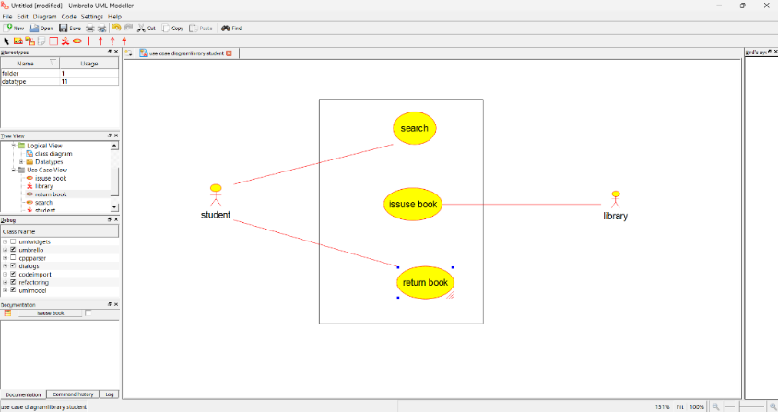
CLASS DAIGRAM:
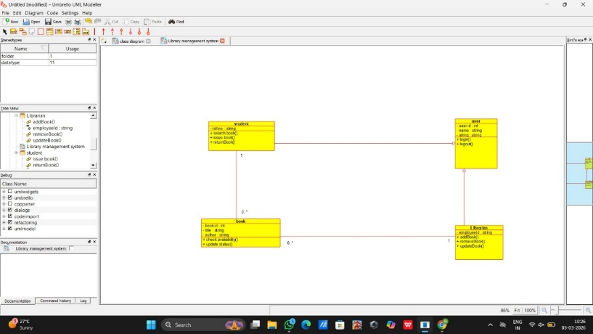
SEQUENCE DAIGRAM:
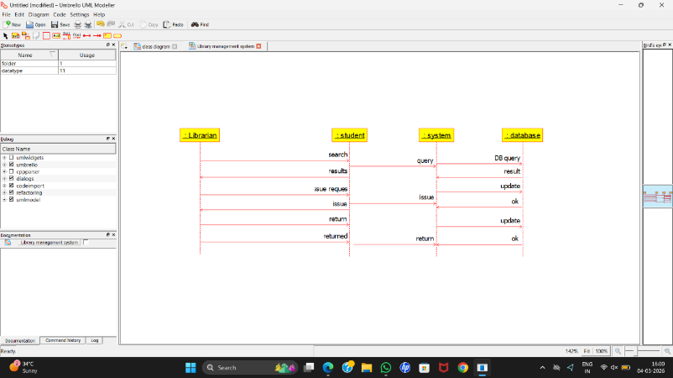

ACTIVITY DAIGRAM:
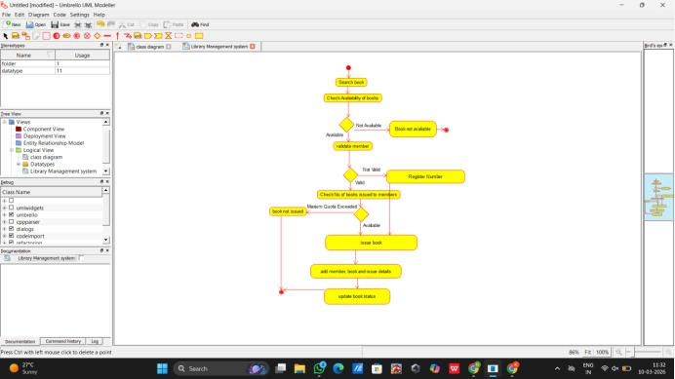

Result
The system successfully manages book searching, issuing, and returning, improving library efficiency and reducing manual work.

2. Online Shopping / E-Commerce System
Aim
To develop an online shopping system where users can search products, add them to the cart, checkout, and make payments.
Algorithm
- User logs into the system.
- User searches for products.
- User adds selected products to cart.
- User proceeds to checkout.
- System calculates total price.
- User completes payment.
- System confirms order.
USE CASE DAIGRAM:
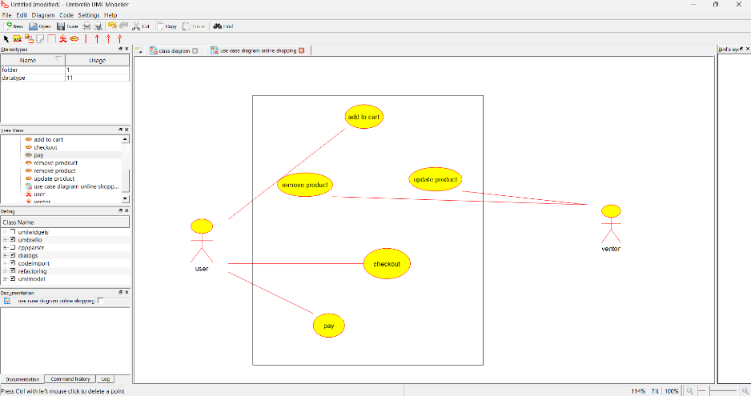
CLASS DAIGRAM:
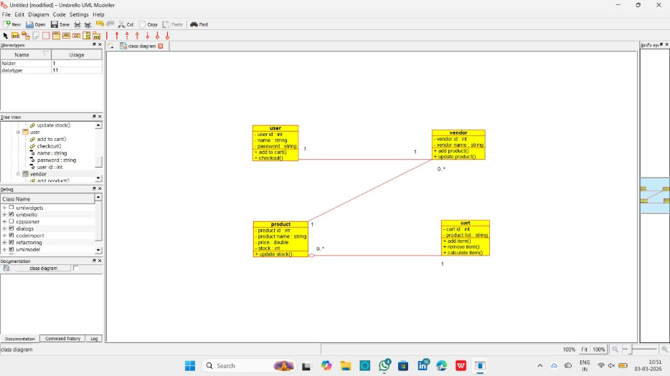
SEQUENCE DAIGRAM:
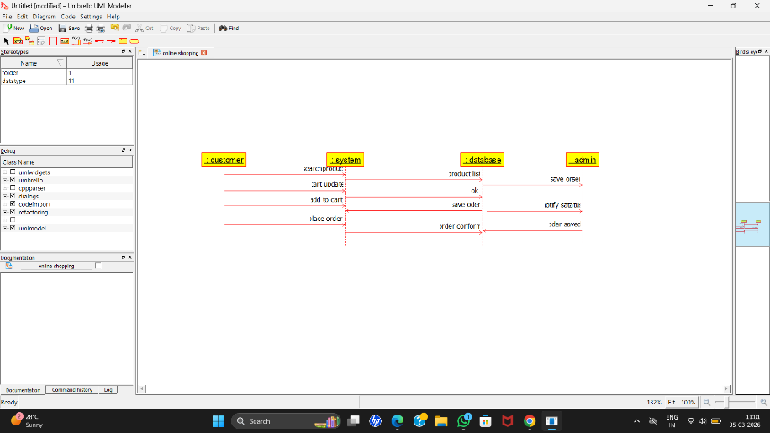
ACTIVITY DAIGRAM:
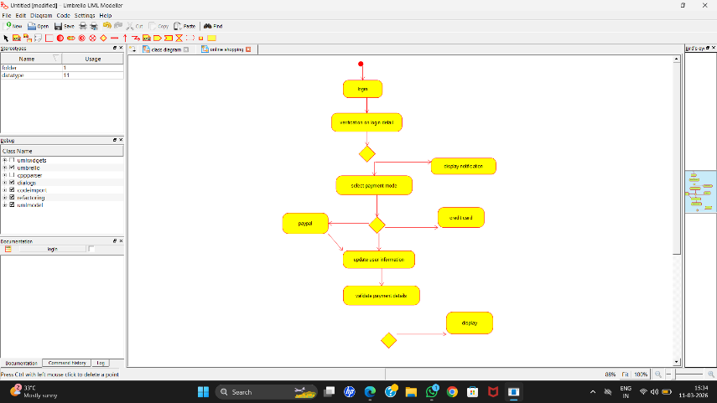

Result
The system successfully manages book searching, issuing, and returning, improving library efficiency and reducing manual work.

3. Hospital Management System
Aim
To design a Hospital Management System to manage patient records, doctor consultations, and appointment scheduling.
Algorithm
- Patient registers at reception.
- Receptionist creates patient record.
- Patient books appointment.
- Doctor checks patient.
- Doctor prescribes treatment.
- System updates medical record.
USE CASE DAIGRAM:
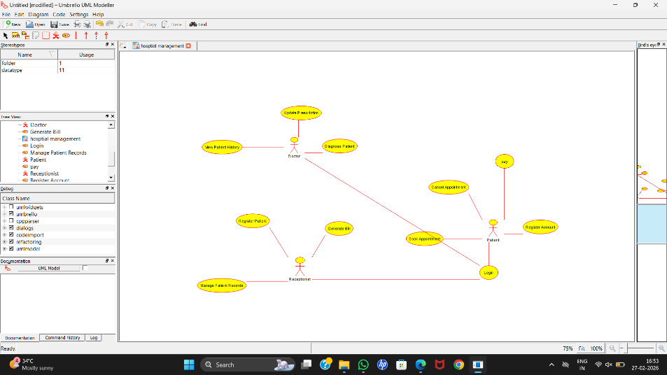

CLASS DAIGRAM:
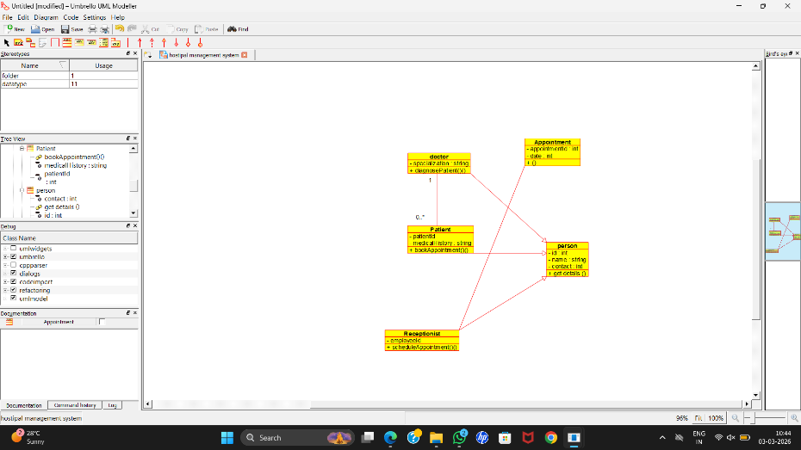
SEQUENCE DAIGRAM:
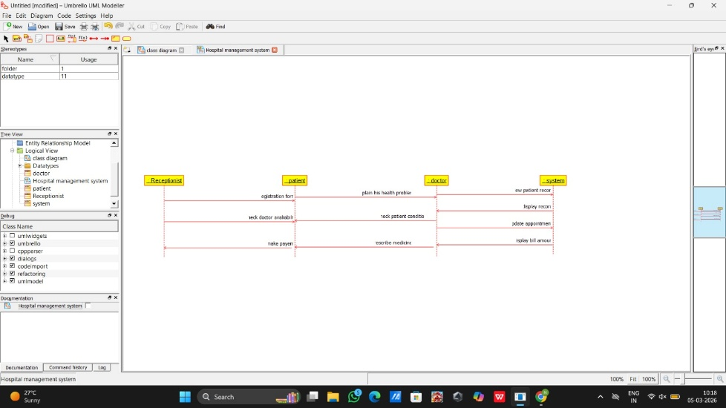
ACTIVITY DAIGRAM :
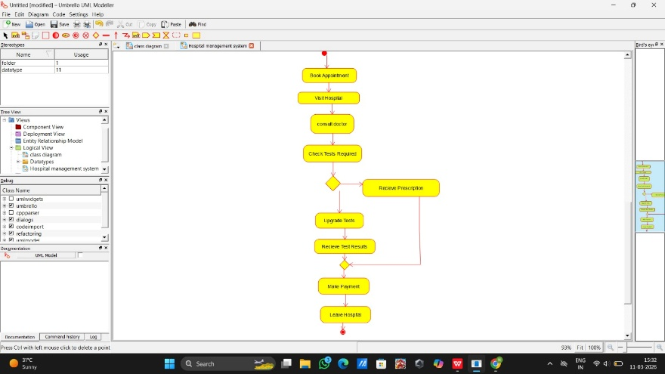
Result
The system successfully manages book searching, issuing, and returning, improving library efficiency and reducing manual work.

4. Railway Reservation System
Aim
To develop a Railway Reservation System that enables passengers to book tickets, cancel tickets, and check ticket status.
Algorithm
- Passenger logs into the system.
- Passenger searches train.
- Passenger selects seat and books ticket.
- System processes payment.
- Ticket generated.
- Passenger can cancel ticket if required.
USE CASE DAIGRAM:
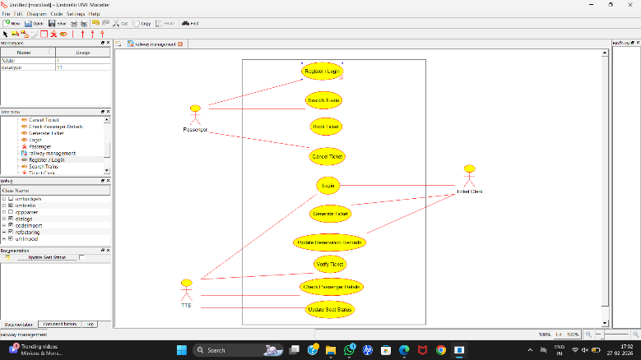

CLASS DAIGRAM:
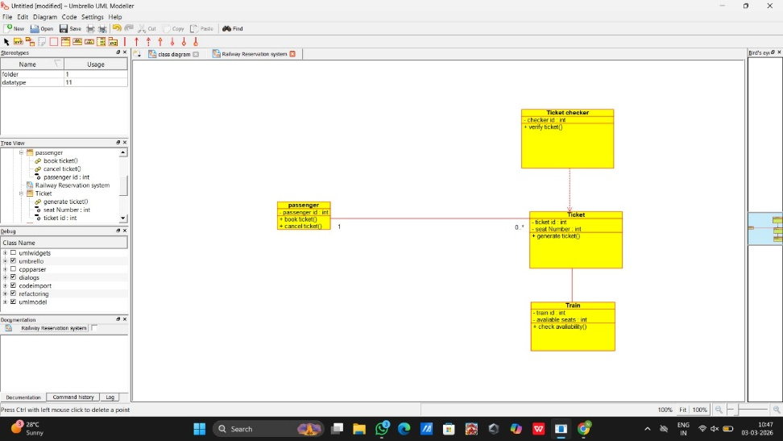
SEQUENCE DAIGRAM:
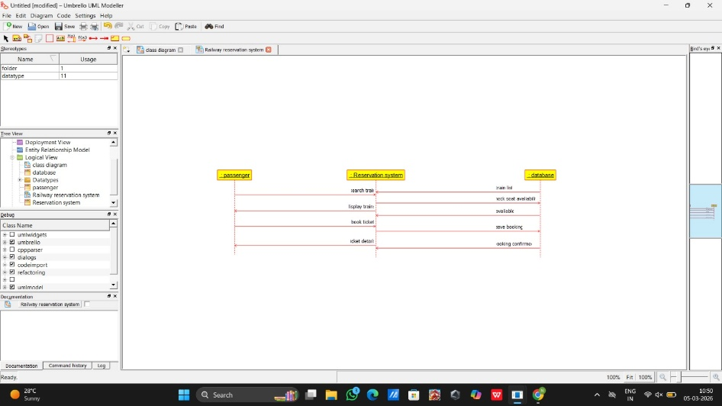
ACTIVITY DAIGRAM:
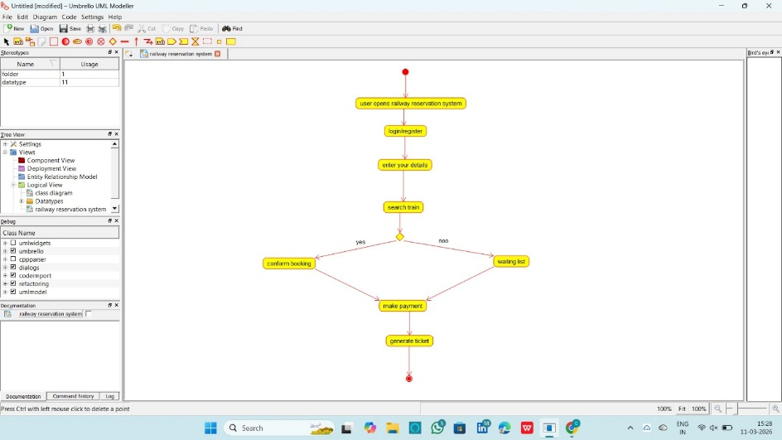
Result
The system successfully manages book searching, issuing, and returning, improving library efficiency and reducing manual work.

5. Student Information System (SIS)
Aim
To design a Student Information System that manages student records, course enrolment, and academic information.
Algorithm
- Student logs into the system.
- Student enrolls in courses.
- Teacher updates grades.
- Administrator manages student records.
- System generates reports.
USE CASE DAIGRAM :
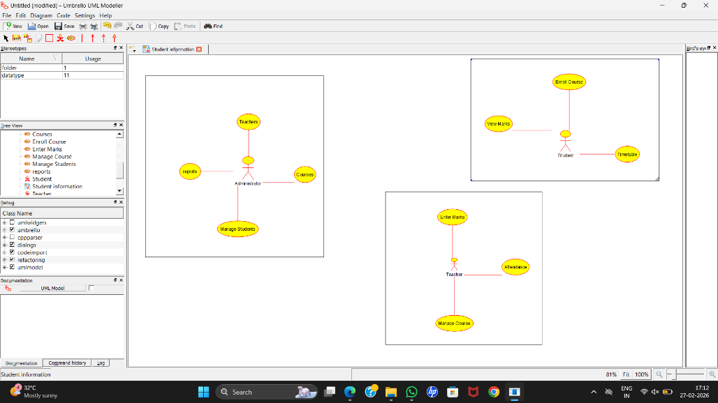

CLASS DAIGRAM:
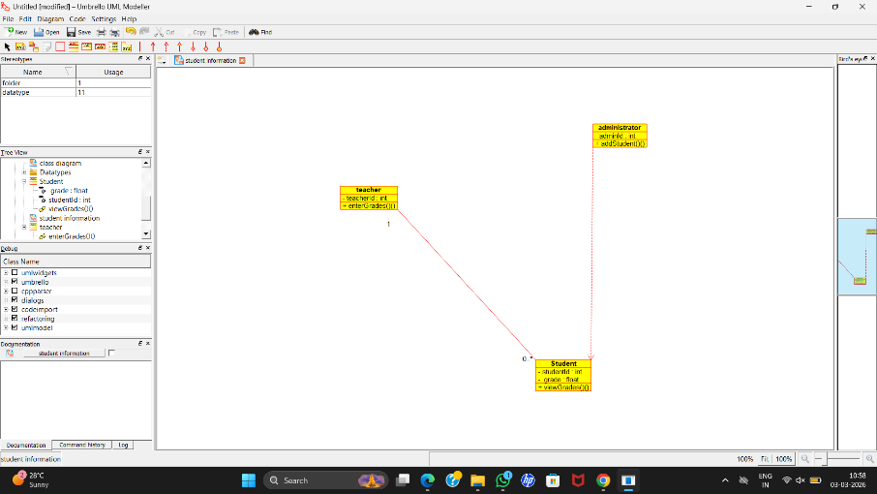
SEQUENCE DAIGRAM:
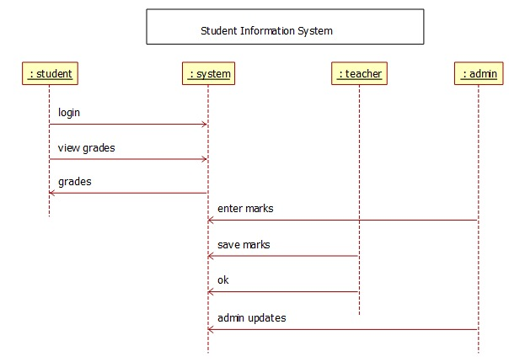
ACTIVITY DAIGRAM:
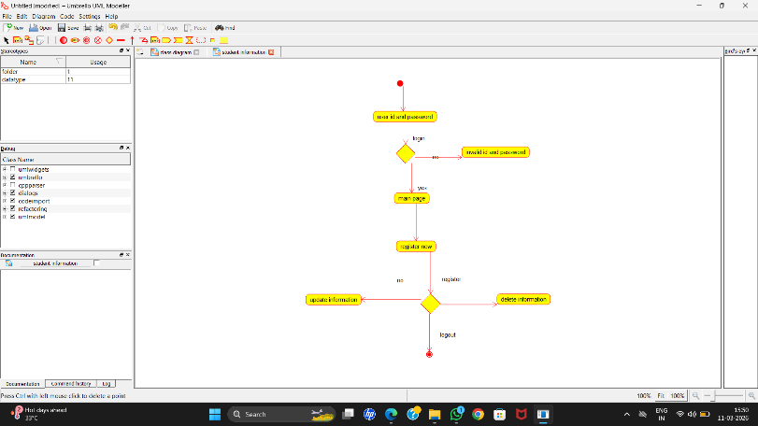

Result
The system successfully manages book searching, issuing, and returning, improving library efficiency and reducing manual work.

6. Employee Payroll System
Aim
To design an Employee Payroll System that manages employee salary calculation and payroll processing.
Algorithm
- Admin enters employee details.
- System calculates salary based on attendance.
- System deducts tax.
- System generates payslip.
- Employee views salary details.
USE CASE DAIGRAM:
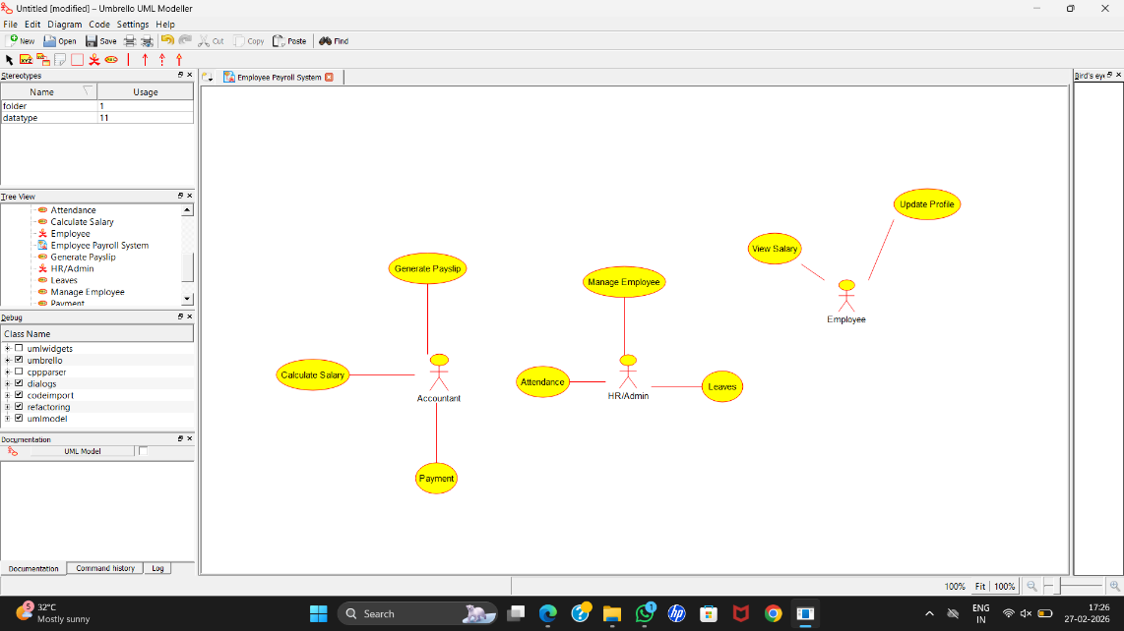
CLASS DAIGRAM:
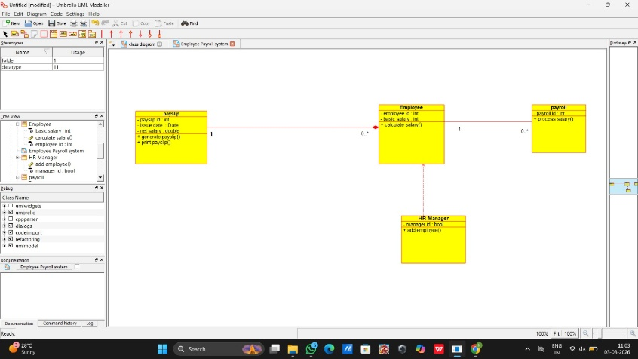
SEQUENCE DAIGRAM :
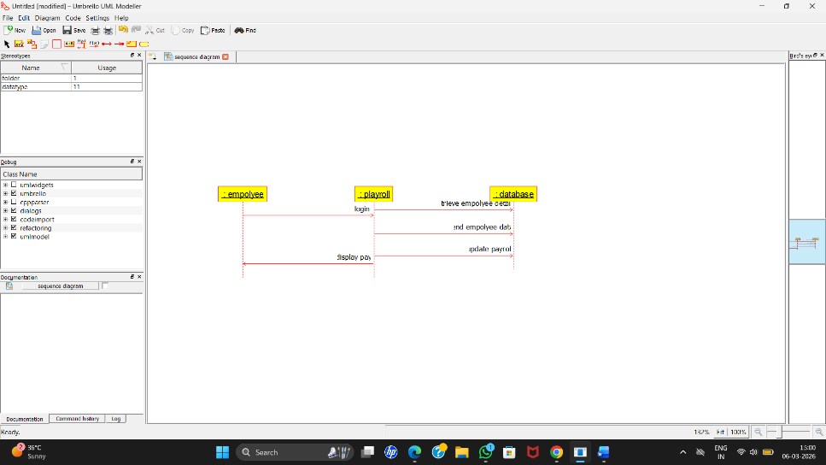
ACTIVITY DAIGRAM:
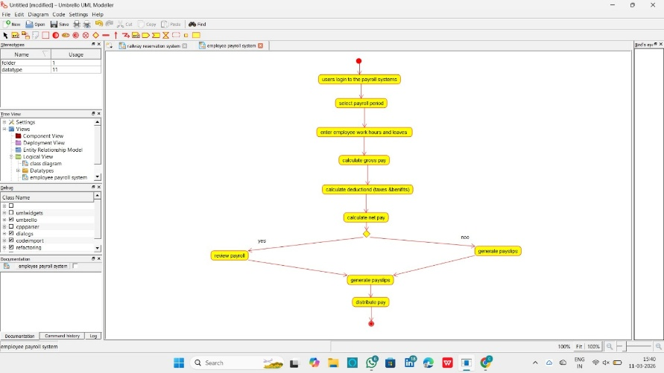

Result
The system successfully manages book searching, issuing, and returning, improving library efficiency and reducing manual work.

7. University Management System
Aim
To design a University Management System that manages course registration, grade entry, and transcript generation for students while allowing teachers and administrators to maintain academic records efficiently.
Algorithm
- Start the system.
- Student logs into the university portal.
- Student selects and registers for available courses.
- System verifies course availability and updates enrollment records.
- Teacher enters student grades after course completion.
- System stores grades in the academic database.
- Administrator generates student transcripts based on recorded grades.
- Student can view or download the transcript.
- End.
USE CASE DAIGRAM :
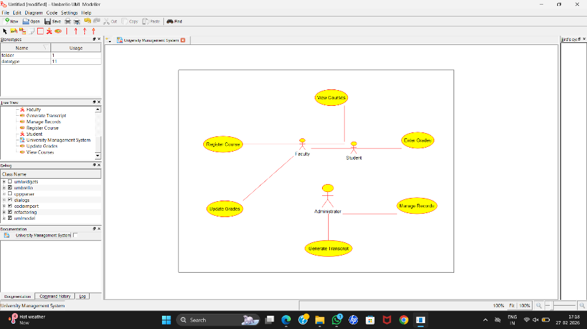
CLASS DAIGRAM:

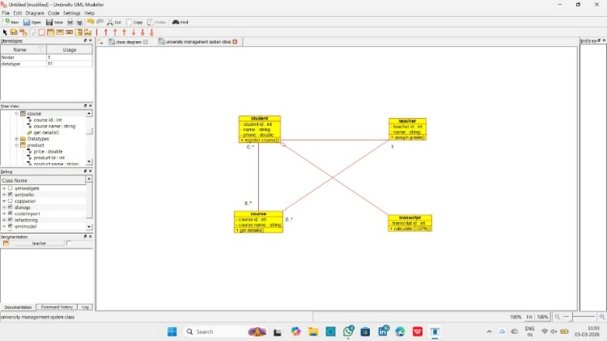
SEQUENCE DAIGRAM :
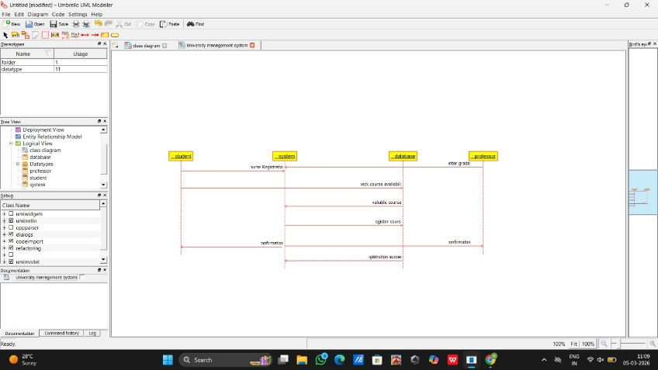

ACTIVITY DAIGRAM:
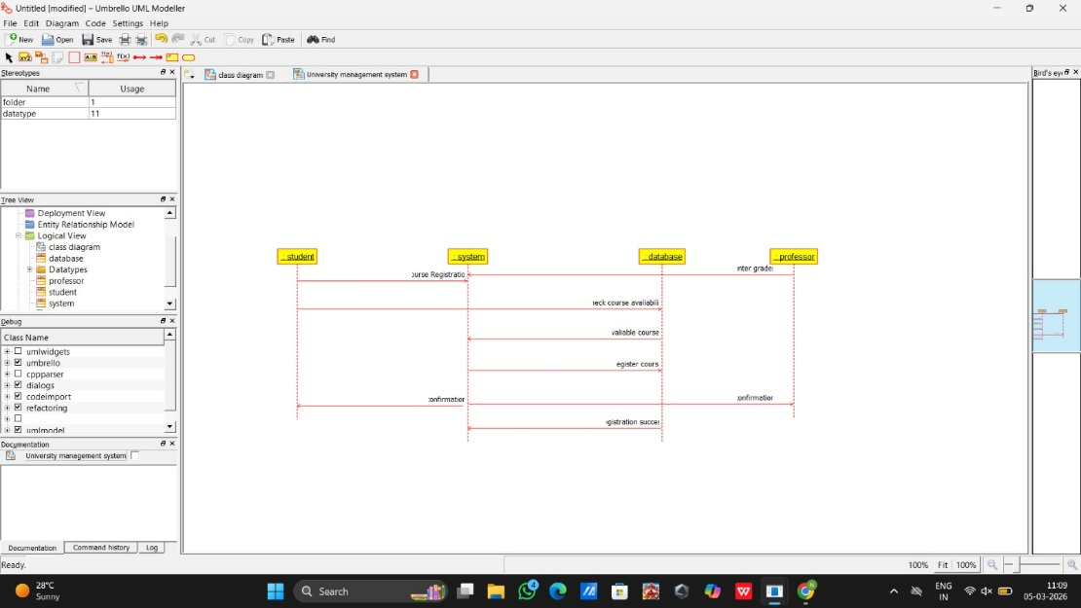
Result
The system successfully manages book searching, issuing, and returning, improving library efficiency and reducing manual work.

